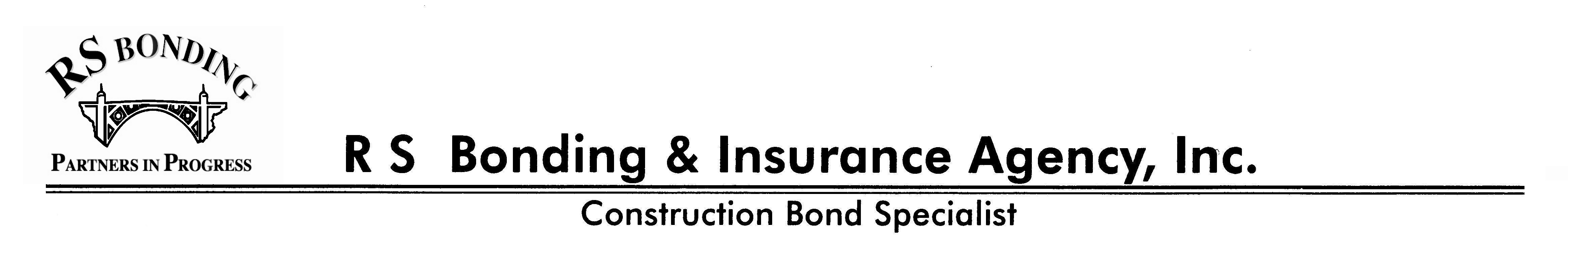

Express Bonding Questionnaire

Company Name:
The name of the company must be its exact legal name, as it appears on license. |  |  |  |  |  |  |  |  | License No.
Address:
 |  | Street City State Zip
Phone: |  |  |  | Fax: |  |  | Federal Tax ID#:

Email: |  | Your firm is a: Corporation Partnership Sole Proprietorship

Type of Construction Performed:

________________________________ History __________________________________

Date Business Established: |  |  | Date Incorporated: |  | State of Incorporation:
Years of Experience
Current / Prior Bond Company(s):

__________________ Organization / Owners and Key Employees __________________

List all Officers; include each owner with 5% or more ownership.

Name |  | Position |  | % of Stock |  | Date of Birth |  |  | Social Security
Spouse:
Spouse:
 |  | Declaration
 |  | Owner | Spouse |  | Owner |  | Spouse
 | How is your credit? | Poor, Fair, Excellent | Poor, Fair, Excellent |  | Poor, Fair, Excellent |  | Poor, Fair, Excellent
 | Bankruptcy in the last seven years? | Yes / No | Yes / No |  | Yes / No |  | Yes / No
 | Any Tax Liens or Judgements? | Yes / No | Yes / No |  | Yes / No |  | Yes / No
 | Do you have a Family Trust | Yes / No | Yes / No |  | Yes / No |  | Yes / No

______________________________ Job Experience ______________________________

Largest Single Job Completed:$ |  |  |  |  |  |  |  |  |  | Year:
Largest Single Job Ever Bid: $ |  |  |  |  |  |  |  |  |  | Year:
Bonding Capacity Desired: Single Job Size: $ |  |  |  |  |  | Total Work Program: $
Largest work on hand at any one time was: $ |  |  |  |  |  |  | during |  | (yr.) |  |  | and consisted of |  |  | (#) contracts.

