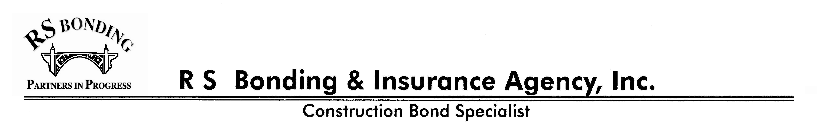

1633 E. Fourth St., #228 Santa Ana, CA 92701 Phone: (714) 541-4700 Fax: (714) 541-4740

COMPLETE TOP PORTION ONLY. PLEASE SIGN BY “X.”

BANK VERIFICATION: Please complete and sign the top portion, then send or fax to your bank(s) for them to complete and send or fax back to us. Thank you for your help and your timely response.

Name and Address of Business Accounts: |  |  | Name and Address of Bank:
Account Nos.
 |  |  | Attention:
Name and Address of Personal Accounts:
 |  |  | The undersigned hereby authorizes the following
 |  |  | information to be released to:
 |  |  | R S Bonding & Insurance Agency, Inc.

Account Nos.
 |  |  | X |  |  |  | / |  | /
 |  |  | Signature Date

BANK COMPLETES BOTTOM PORTION
THE CONFIDENIALITY OF THIS INFORMATION WILL BE PRESERVED EXCEPT WHERE DISCLOSURE OF THIS INFORMATION IS REQUIRED BY APPLICABLE LAW. WE WILL NOT HOLD YOU OR ANY STAFF MEMBER RESPONSIBLE FOR ITS ACCURACY.
We have been asked to write bonds or are currently writing bonds for the above applicant, and your bank has been given as a reference. Please complete the following:

DEPOSITORY ACCOUNTS: Please Complete Account Information Using Actual Dollar ($) Figures – Please No Ranges !

This customer has been with our bank since ______________________

Average Balance Any Overdrafts?
Account No. Type Past 6 months Current Balance Floats? Returned Checks?

______________ ___________ $_________________ $_________________ _______________________

______________ ___________ $_________________ $_________________ _______________________

______________ ___________ $_________________ $_________________ _______________________

______________ ___________ $_________________ $_________________ _______________________

CREDIT ACCOUNTS:

We Have Granted Them Credit Since _______________________ Current Line of Credit Extended $_____________________

Is the Line Secured?___________ If so, by what?_______________________________________________________________

Current Balance of the Line________________________ Renewal Date of the Line____________________________________

Has the Line Been Handled as Agreed? _______________________________________________________________________

Other Loans Extended: Current Balance $ ________________________Monthly Payments$ _____________________________

Are These Secured? _____________If so, by what? _____________________________________________________________

Has These Been Handled as Agreed?_________________________________________________________________________

Your Experience and Opinion of this Applicant’s Financial Responsibility and Business Reputation: ________________________

_______________________________________________________________________________________________________

_______________________________________________________________________________________________________

_______________________________________________________________________________________________________
Thank you for your cooperation.

BANK OFFICER: ________________________________________________ ___________________________________
Signature and Printed Name Date

________________________________________________

Phone

