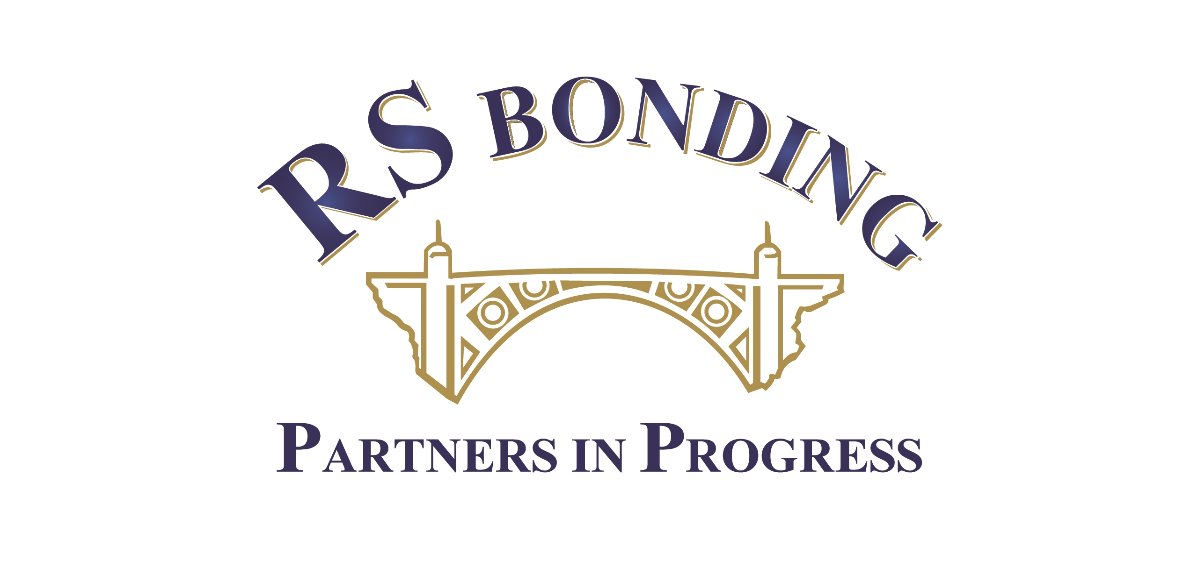 |  |  |  |  |  |  | Developer/Subdivision/Permit  Bond Application
Producer Name  R S Bonding & Insurance Agency, Inc. |  | Producer Phone  714-541-4700 |  |  |  | Producer Contact  Randy Spohn
Applicant Name (As it is to appear on BOND)

If Applicant is a Business, please state the NAME and TITLE of owner: |  |  |  |  |  |  |  | Social Security Number
Home Street Address: |  |  |  |  |  |  |  | Phone
City |  |  |  | State |  |  |  | Zip
Business Street Address: |  |  |  |  |  |  |  | Phone
City |  |  |  | State |  |  |  | Zip
Type of Project (Commercial, Retail, Mixed-Use etc.)

Address or Location of work: |  |  | Type of Work? (Grading, Street, Curb, Gutter etc.)
When will work start: |  |  | Who is performing the construction?

How is work being financed?

Obligee Name |  |  | Obligee Address
Tyoe of Bond(s) | Bond Amount(s) |  |  |  | Provide: Financial Statement of Operating Entity( If Any); Personal Financial Statements; Government Approved Bond Estimate; and Bond Form.

